Summary of the Advice | Angela and Kevin were retiring at the end of May and closing down their business. Thye were seeking advice as they need to generate an income of £3,500pm from August and only have Kevin's State Pension as income for the next 3 years until Angela gets her State Pension. They have never sought advice before and had a bad experience with the initial Advice Firm they contacted. Advice is to use their Pensions to produce a combined initial income of £2,466.34 on top of Kevin's State Pension. Angela has her PA available. My thoughts are we utilise Angela's PA and set up reg UFPLS of £1,396.66pm with remaining income to be met by their Cash ISA's. This will meet their retirement income need and all income would be Tax Free.
Justification for the initial and ongoing fee | Both clients are in expensive products with fees ranging from 0.75% pa to 1% pa for Platform and Investment Costs. They want a trusted adviser that will look after them and provide good quality on-going management of their invested assets and help them acheive their income and capital needs in the most tax effeicient way.
Income/ Expenditure Goal and Retirement | Total Income needed is £3,500pm incuding Kevin's current State Pension. Angela has PA available and does not get SP until Oct 2029. They have variable rate Cash ISA which can be used as part of their income strategy

- Angela has a Prudential With profits pension. There is no explicit charge attached to the plan but it is quoted that on average it is 0.95%. this is detailed on the policy information and in the PPFM.
- The Pru plan current has no MVR and a bonus of £22,510.79. while the plan is in the strong position it would be a good time to switch the pension.
- The Pru plan only has with profits as the fund option, limiting the clients options for switching funds. This fund is also outside the clients risk portfolio.
- The Pru plan has no drawdown options, the plan has to be internally moved or externally to start taking the pension. This is something the client would like to turn on as Angela has PA available which we should use to take now while she has no income.
- Prudential does not allow Adviser charging which the client would benefit from now they are entering drawdown and will be reliant on the pension partially now and in the future.
- Angela also has a Phoenix Pension, that is expensive at 0.75%. this alongside the client wanting to access her pensions is enough justification to move this pension to a platform under our practice.
- In the phoenix plan the client has access to 13 funds, none of which are multi asset funds, they appear to be single asset class funds. We would need to manually balance these funds continuously to ensure they remain a risk level 4. There is a managed fund, I have run this through our risk rater which has come out higher than a risk level 4. An internal fund switch has been discounted. The plan is also not fit for the client based on other reasons explained.
- Angela’s Phoenix plan does not have access to Flexi access drawdown just Full UFPLS. This limits the clients options in the future once her state pension states in October 2029.
- Once consolidated we will be able to manage the pension and set up the drawdown for the client.
Prudential – Both Clients. (no other funds to research) |  |  | Performance
Fund name | Risk | AMC | 1 | 3 | 5
With profits | 5 | 0.95%

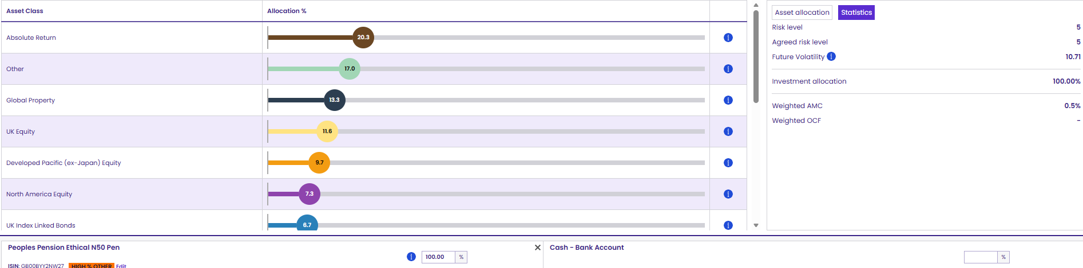

- Kevins has the same Pru Withprofits pension as Angela. This means that it has the same characteristics. No adviser charging, no drawdown options, 1 fund which doesn’t align to the clients risk. Limits his growth potential in his risk profile. The fund is also expensive at 0.95%
- Kevin currently has no MVR and has a bonus of £11,297.20. while the plan is in the strong position it would be a good time to switch the pension.
- No fund research to be done on the Prudential plan.
- Kevin also has a Standard Life With profits plan, again there is no MVR on this plan, there is a bonus of £1,016.80, the plan charge is 1% which is more expensive than we can offer. There are no other funds that the client can switch into, no fund research done for standard Life.
- The plan has no FAD but id does have UFPLS full or Partial.
- The plan doesn’t have adviser charging availbe on this plan, the client is now seeking advice as they are starting their retirement together and would like the best from their pensions plus ensure they are able to use them for their full retirement.
- Both clients are cautious investors and need hand holding throughout retirement to ensure they are making the most of their pensions.

Phoenix – Angela* |  |  | Performance
Fund name | Risk | AMC | 1 | 3 | 5
AL Pensions International | 9 | 0.75%
AL managed | 6 | 0.78%
*Unit-linked fund prices – Abbey Life

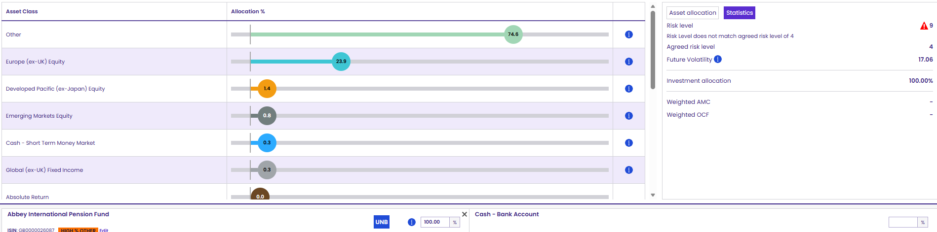
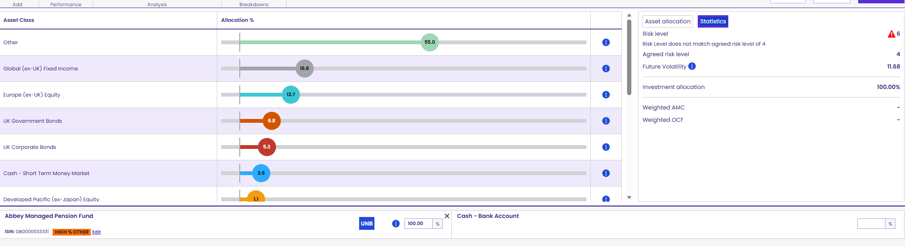
Angela is a risk level 4, I propose we use HSBC Conservative and Vanguard 40% to keep it passive while she is drawing on the pension.
Kevin is a risk level 5, I propose we use CT Balanced and Vanguard 60%, to give a good mix of passive and active.
Both clients are a little weary and new to investing, do not want to put them in full active and cause additional risk to their funds, considering they are thinking about drawing from Angela’s pot.

Total income need is £3500 net per month.
Kevin is currently in receipt of his state pension at £954.15 every 4 weeks (£1,033.66 per month)
Angela has her full PA to use this year £1,047.50 can be taken each month tax free from the pension but as a taxable amount. We can get approx. £1309.37 out of the pension as a UFPLS all tax free due to £261.87 being tax free and £1,047.50 being taxable (tax free within allowance)
This will leave the clients with a £1,156.97 deficit. The clients currently have £276,000 in various cash accounts. This will support the deficit easily and will be the most tax efficient way to do it. Once angela’s state pension starts in 2029, we will re-assess the suitability of the pension withdrawal and cash position.
Annuity Quotes produced for Angela due to her taking income. Discounted as she wants flexibility and this wouldn’t give her the controlled over the tax free withdrawals she requires until state pension, based on the quotes this doesn’t give the client what she needs at this time
Decide on Aviva as they have better administration for us and the client.
Aegon are slightly cheaper at 0.20% rather than Aviva at 0.21%. however this cost isn’t that much over the year and Angela would like to start drawing down on her pension meaning we need ease of administration for the client, which Aegon currently do not provide.

